EF-101 | FALL 2026

NED University of Engineering & Technology
Electrical Engineering Department



File Storage,
Compression and Backup Investigation
  - Executive Technical Report
━━━━━━━━━━━━━━━━━━━━━━━━━━━━━━━━━━━━

Course | EF-101 — IT Fundamentals & Applications
Project ID | EF101-P17
Team | Ali - Zeeshan – Tanzeel
Submission date | Monday, 9 November 2026
Primary Experimental Record | ITFA FINAL.xlsx
Instruction source | EF-101 Fall 2026 System Understanding Project Handbook

Executive Summary:
This project investigates how file type affects lossless archive compression, how transfer destination affects observed throughput, and how cryptographic hashes can verify that copied files remain unchanged. The experimental record is maintained in the Excel workbook across the Dataset, Comp, Transfer, Insights, Hashes, Tests and 321Backup sheets. The project is an experimental workflow.
Twelve sample files have a combined original recorded size of 11,372 KB. In the main ZIP run, their individual compressed outputs sum to 4,364 KB, saving 7,008 KB and producing a size-weighted reduction of 61.63%. In the separate 7-Zip run, the recorded outputs sum to 532 KB, a size-weighted reduction of 95.32%. These totals are sums of per-file results in the workbook, not the measured size of one combined archive.
Three members each recorded one USB transfer and one cloud upload for four nominal 100 MB files. Average recorded throughput was 6.42 MiB/s for USB and 1.25 MiB/s for cloud upload; the mean USB rate was 5.15 times the mean cloud rate in these six observations. Six SHA-256 before/after checks all returned PASS. The workbook also contains evidence of 7-Zip compression, an encrypted archive, an automated checksum script and a proposed 3-2-1 backup design.

Key results at a glance:
Measure | Recorded result | Interpretation
Dataset | 12 files | Meets the minimum 12-file dataset and covers required file categories.
ZIP output set | 11,372 → 4,364 KB | 7,008 KB saved; 61.63% weighted reduction.
7-Zip output set | 11,372 → 532 KB | 10,840 KB saved; 95.32% weighted reduction.
Transfer throughput | USB 6.42; cloud 1.25 MiB/s | USB mean was 5.15× cloud mean for these runs.
Integrity checks | 6 / 6 PASS | Before and after SHA-256 strings match for every recorded test.
Backup design | 3 copies, 2 media/types, 1 off-site | Laptop + external storage + cloud copy.

1. Purpose, Scope and Methodology:

1.1 Purpose and objectives:
The P17 objective is to experimentally connect file storage, formats, compression and backup with measurements. The work therefore tests actual sample files, records sizes and transfer times, calculates derived metrics and checks data integrity instead of relying only on definitions.
- Build a dataset containing at least 12 files across text/document, source code, bitmap, JPEG/PNG, audio, video and archive/spreadsheet categories.
- Record original and compressed size; calculate space saved, percentage reduction and compression ratio.
- Compare a ZIP compression run with a separate 7-Zip run, then interpret why observed reductions differ by sample type.
- Measure transfers of four nominal 100 MB files to USB storage and a cloud destination for each team member.
- Verify copied-file integrity using SHA-256 before and after copying
- Define a student-data backup plan using local, external and off-site storage.

1.2 Dataset and recorded evidence:
The Dataset sheet lists 12 samples: WAV, C source, PNG, PDF, TXT, BMP, DOCX, ZIP, MP4, XLS, JPG and MP3. Original sizes range from 17 KB for the PDF sample to 5,626 KB for the BMP sample. The Tests sheet contains screenshots for original files, compressed outputs, transfer work and bonus activities. These screenshots support the recorded workbook tables and are evidence snapshots.

1.3 Metrics and calculation rules:
Metric | Formula | Meaning
Space saved | Original size − compressed size | Absolute reduction in recorded KB.
Size reduction (%) | (Space saved ÷ original size) × 100 | Percentage of the original file size removed by compression.
Compression ratio | Original size ÷ compressed size | Original size expressed as a multiple of compressed size.
Transfer throughput | Actual transferred data (MiB) ÷ elapsed seconds | Approximate transfer rate for the recorded run.
Integrity result | SHA-256 before = SHA-256 after | PASS when the recorded hexadecimal digests match.

1.4 Assumptions and measurement boundaries:
- Each file-format result represents one sample per extension. The content, dimensions, codec, encoding and entropy of each source file may differ; therefore results are sample-specific.
- The workbook records compression outputs and times but does not consistently record archive algorithm, compression level, hardware model, USB generation, cloud provider, network conditions or multiple repeated trials.
- The three members performed their own transfer observations. The differences are informative for these runs but are not a controlled comparison of USB and cloud performance under identical conditions.
- The total compression figures are sums of the twelve per-file outputs in each worksheet. They should not be read as the size of a single multi-file archive.

2. System Architecture and Data Flow:
The architecture below represents the actual investigation pipeline. File-system operations, archiving, hashing and Excel analysis occur on the team’s computers. The USB destination is a separate local medium; the cloud destination is remote and requires an Internet connection. No dedicated application server, database, external API or hardware sensor is implemented in this project.

2.1 Trace of a compression operation:
- The operator selects one of the twelve source files in the local file system.
- The chosen archive tool produces a compressed output; the source file remains the reference for the original-size measurement.
- The operator records original and compressed sizes in the Comp sheet.
- Excel formulas calculate space saved, reduction percentage and compression ratio; the Insights charts then visualize the recorded results.
- The operator compares the results with the file’s format and content, while keeping the original file available for repeatability.

2.2 Trace of a transfer and integrity check:
For the transfer test, four nominal 100 MB files are copied from the computer to a USB destination and to the cloud destination. The actual size total and elapsed time are recorded in Transfer. Throughput is computed as total data divided by time. For integrity verification, SHA-256 is calculated before and after copying a selected file using the recorded Windows command, and the two strings are compared. All six comparisons in Hashes match and are recorded as PASS.

2.3 Where the information is stored:
Information | Storage location / form | Role
Original test files | Local file-system files | Reference inputs for size, compression and transfer.
Compressed outputs | Local file-system archive (output files shown in evidence screenshots) | Measured outputs for ZIP and 7-Zip runs.
Experimental record | Excel workbook; tables, formulas, charts and embedded screenshots | Primary record of measurements and evidence.
Integrity data | Hashes sheet; SHA-256 strings, commands and PASS/FAIL result | Evidence that the tested copies matched.
Transfer destination | USB storage and an unspecified cloud service | Compared local removable-media & upload performance.
Backup concept | Laptop, separate external storage, off-site cloud copy | Proposed protection for important student data.

3. Compression Results and Interpretation:
The twelve original samples total 11,372 KB. The ZIP run’s per-file outputs total 4,364 KB, saving 7,008 KB. This is a size-weighted reduction of 61.63%; the unweighted mean of the twelve individual percentage reductions is 55.75%.
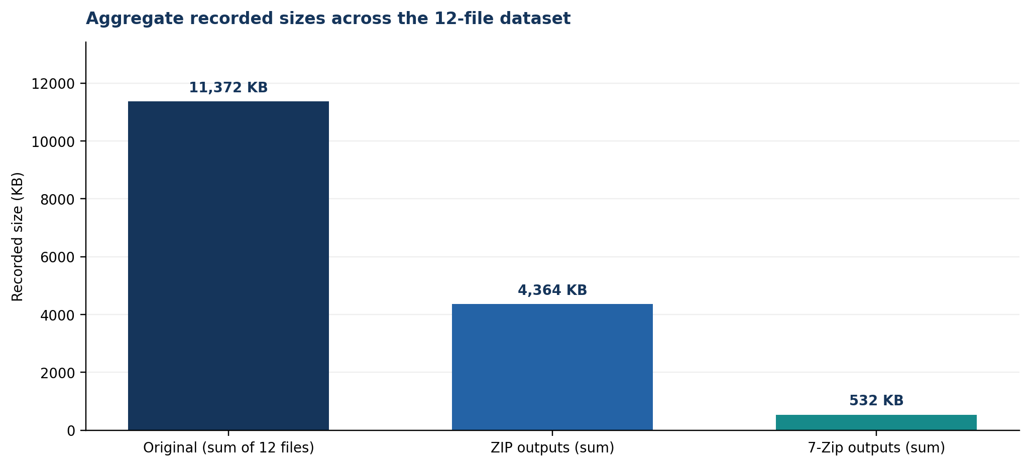
Figure 2. Sum of recorded per-file sizes for the original dataset and the two compression runs.

3.1 File-level ZIP result
The complete twelve-file table, including all original and compressed sizes, space saved, reduction percentage and compression ratio, is presented below:
Member | Sample / type | Original KB | Compressed KB | Saved KB | Reduction % | Ratio
Ali | test_audio.wav | 2,585 | 22 | 2,563 | 99.15% | 117.50:1
Ali | test_program.c | 167 | 2 | 165 | 98.80% | 83.50:1
Ali | test_image.png | 36 | 21 | 15 | 41.67% | 1.71:1
Ali | test_document.pdf | 17 | 8 | 9 | 52.94% | 2.12:1
Zeeshan | test_text.txt | 982 | 5 | 977 | 99.49% | 196.40:1
Zeeshan | test_bmp.bmp | 5,626 | 3,633 | 1,993 | 35.42% | 1.55:1
Zeeshan | test_document.docx | 37 | 34 | 3 | 8.11% | 1.09:1
Zeeshan | test_archive.zip | 93 | 93 | 0 | 0.00% | 1.00:1
Tanzeel | test_video.mp4 | 127 | 115 | 12 | 9.45% | 1.10:1
Tanzeel | test_data.xls | 715 | 89 | 626 | 87.55% | 8.03:1
Tanzeel | test_image.jpg | 282 | 71 | 211 | 74.82% | 3.97:1
Tanzeel | test_audio.mp3 | 705 | 271 | 434 | 61.56% | 2.60:1

The best ZIP reductions in this sample were TXT (99.49%), WAV (99.15%) and C source (98.80%). XLS reduced by 87.55%; JPG by 74.82%; MP3 by 61.56%; and PDF by 52.94%. PNG reduced by 41.67%. The BMP file was the largest input and reduced from 5,626 KB to 3,633 KB (35.42%). In contrast, DOCX decreased by only 8.11%, MP4 by 9.45%, and the existing ZIP sample showed no size reduction in the main ZIP run (93 KB before and after).

3.2 Why formats behaved differently:
- Plain text and source code often contain repeated strings, whitespace, predictable tokens and other redundancies. Dictionary-based and statistical lossless methods can encode those patterns compactly; the TXT and C samples were consistent with this expectation.
- A bitmap can contain repeated or correlated pixel data that lossless compression can exploit. The BMP result was moderate under the main ZIP run but much stronger under the 7-Zip run, underscoring the effect of tool settings and sample content.
- JPEG images, MP3 audio and MP4 video commonly use lossy or otherwise highly compressed coding. An additional general-purpose archive often finds little remaining redundancy; the MP4 result was only about 9.45% smaller in the ZIP run. However, the sampled JPG and MP3 did reduce, so “already compressed” means limited expected benefit, not zero benefit in every case.
- DOCX is a packaged document format that uses ZIP-based packaging internally, which helps explain its small additional reduction. PDF compression varies with whether content is text, scanned images, embedded fonts, or already-compressed objects; this one small PDF is not representative of every PDF.
- The existing ZIP sample stayed at 93 KB in the main ZIP run but became 22 KB in the 7-Zip output. This is an observed tool/output difference. Because the archive method, settings and archive internals are not specified, the report does not claim this proves a universal property of ZIP files.

4. Separate 7-Zip Run & Compression Theory:
The workbook’s bonus table records a separate 7-Zip compression run. The twelve per-file outputs sum to 532 KB, a reduction of 10,840 KB, or 95.32% weighted reduction against the same 11,372 KB original total. The unweighted mean of per-file reductions is 71.60%. These totals must be understood as worksheet sums of individual outputs, not a single archive’s storage footprint.

4.1 Separate 7-Zip run:
The complete twelve-file table, including all original and compressed sizes, space saved, reduction percentage and compression ratio, is presented below:
Member | Sample / type | Original KB | Compressed KB | Saved KB | Reduction % | Ratio
Ali | test_audio.wav | 2,585 | 5 | 2,580 | 99.81% | 517.00:1
Ali | test_program.c | 167 | 1 | 166 | 99.40% | 167.00:1
Ali | test_image.png | 36 | 20 | 16 | 44.44% | 1.80:1
Ali | test_document.pdf | 17 | 8 | 9 | 52.94% | 2.12:1
Zeeshan | test_text.txt | 982 | 1 | 981 | 99.90% | 982.00:1
Zeeshan | test_bmp.bmp | 5,626 | 193 | 5,433 | 96.57% | 29.15:1
Zeeshan | test_document.docx | 37 | 34 | 3 | 8.11% | 1.09:1
Zeeshan | test_archive.zip | 93 | 22 | 71 | 76.34% | 4.23:1
Tanzeel | test_video.mp4 | 127 | 114 | 13 | 10.24% | 1.11:1
Tanzeel | test_data.xls | 715 | 32 | 683 | 95.52% | 22.34:1
Tanzeel | test_image.jpg | 282 | 45 | 237 | 84.04% | 6.27:1
Tanzeel | test_audio.mp3 | 705 | 57 | 648 | 91.91% | 12.37:1

The recorded 7-Zip outputs were markedly smaller for several files: BMP fell from 5,626 KB to 193 KB (96.57%); XLS from 715 KB to 32 KB (95.52%); MP3 from 705 KB to 57 KB (91.91%); and JPG from 282 KB to 45 KB (84.04%). DOCX remained at 34 KB and MP4 fell only from 127 KB to 114 KB (10.24%). The results support the conclusion that compression benefit depends on both the data and the chosen tool/configuration.

4.2 Lossless versus lossy compression:
Lossless compression represents the original information exactly; after decompression, the original bytes can be recovered. This is appropriate for source code, spreadsheets, documents and backups where a bit-level change may be unacceptable. ZIP and 7-Zip archives are used here as lossless archive workflows. Lossy compression discards some information to reduce size, typically trading fidelity for space or bandwidth; JPEG, MP3 and common video codecs are examples of formats that often use lossy encoding. Archiving a JPEG or MP3 in ZIP does not reverse the information discarded when the media was originally encoded.

4.3 Why repeated compression may have limited value:
If a file already uses an efficient compressor, much of its redundant structure has already been removed. Compressing it again with a similar general-purpose method may therefore add little benefit, and archive headers can offset small gains. The main ZIP run’s ZIP sample (93 KB to 93 KB) illustrates no additional size reduction. The 7-Zip run’s 93 KB to 22 KB result is a counterexample to any absolute claim that a compressed archive cannot shrink further; the internal contents and differing settings may have allowed additional savings. Since the workbook does not record the underlying archive method/level, this remains a plausible explanation, not a proven causal finding.

4.4 Zip VS 7-zip:
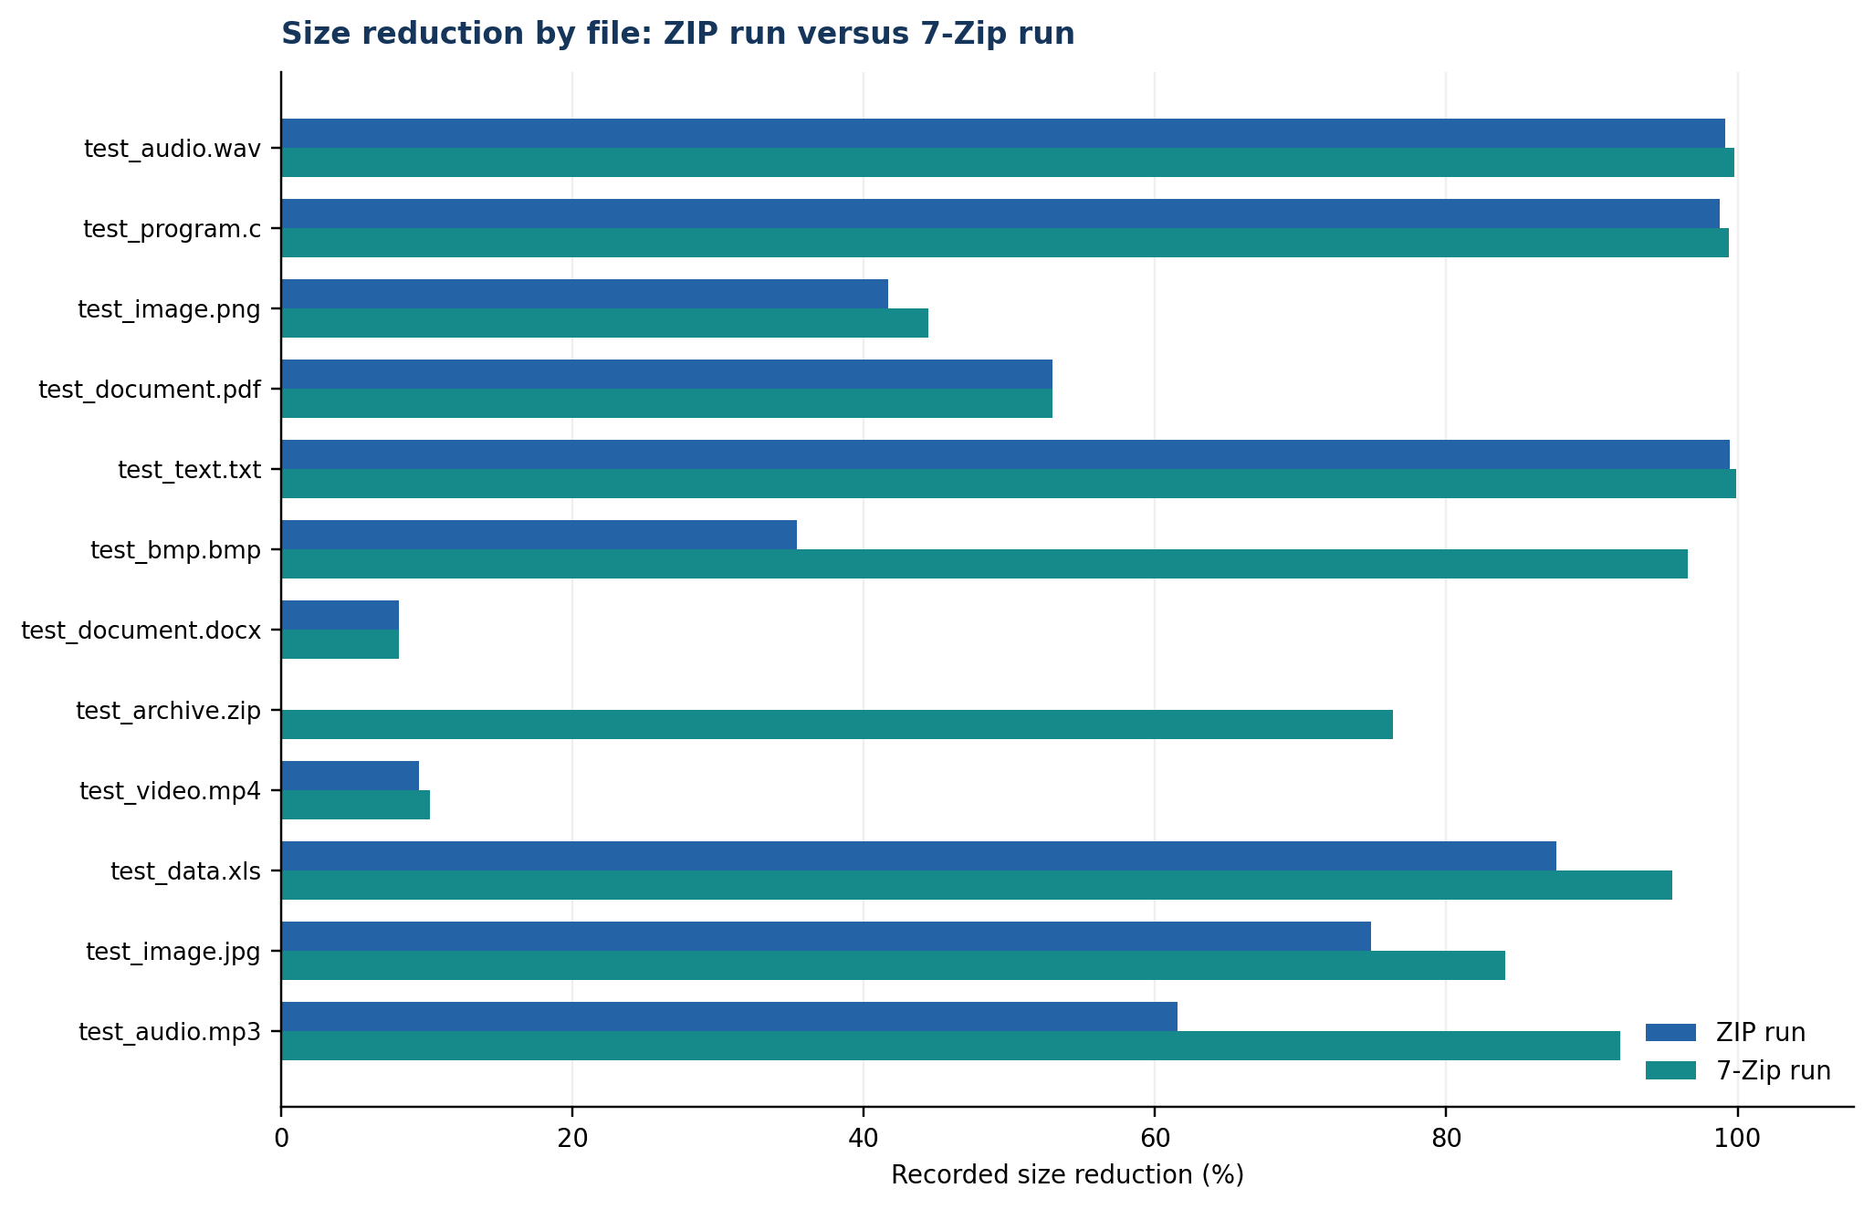
Figure 3. Per-file percentage reduction in the ZIP and 7-Zip runs.

5. Transfer Performance:
Each member recorded a Computer → USB run and a Computer → Cloud run for four nominal 100 MB test files. The total sizes reflect the actual combined sizes in the evidence, rather than assuming exactly 400 MB. Transfer rate is calculated by dividing actual transferred data by elapsed seconds. For technical clarity, this report expresses the converted totals and rates in MiB and MiB/s using 1,024 KB per MiB.

Member | Destination | Files | Total data (MiB) | Time (s) | Rate (MiB/s)
Ali | USB | 4 | 404.003 | 55 | 7.346
Ali | Cloud upload | 4 | 404.003 | 360 | 1.122
Zeeshan | USB | 4 | 400.484 | 92 | 4.353
Zeeshan | Cloud upload | 4 | 400.484 | 1,025 | 0.391
Tanzeel | USB | 4 | 401.255 | 53 | 7.571
Tanzeel | Cloud upload | 4 | 401.255 | 180 | 2.229

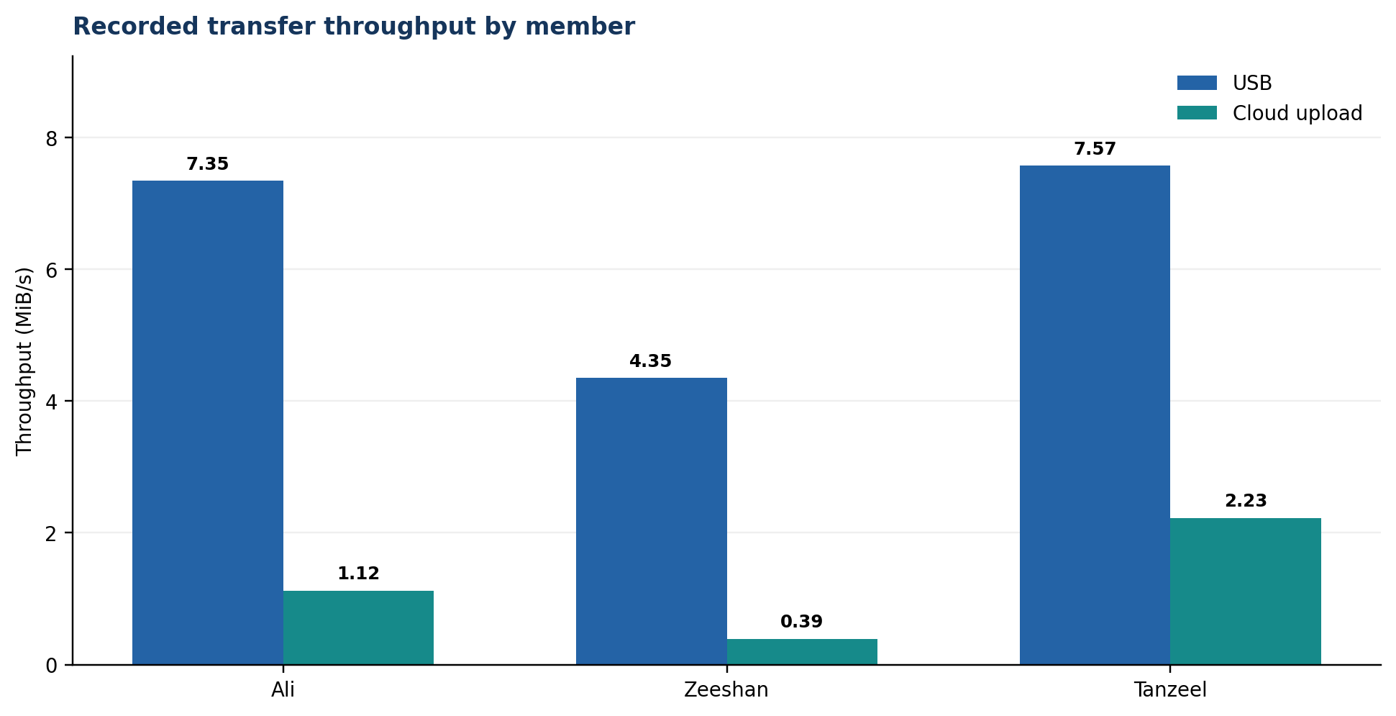
Figure 4. Recorded throughput for USB and cloud-upload runs; individual observations, not repeated controlled trials.

5.1 Results:
The three USB observations were 7.346, 4.353 and 7.571 MiB/s, averaging 6.423 MiB/s. The three cloud-upload observations were 1.122, 0.391 and 2.229 MiB/s, averaging 1.247 MiB/s. The USB mean was 5.15× the cloud mean for this set of runs. Aggregate recorded elapsed time was 200 seconds across the three USB runs and 1,565 seconds across the three cloud-upload runs.
Zeeshan’s cloud upload took the longest (1,025 seconds) and yielded the lowest recorded cloud rate (0.391 MiB/s). Tanzeel’s cloud upload was the fastest cloud observation (2.229 MiB/s). These differences may reflect network conditions, cloud-service processing, local hardware or timing differences; the workbook does not record enough metadata to isolate one cause.

5.2 Practical interpretation:
- For large one-time transfers under the measured conditions, the tested USB route had higher observed throughput than the cloud upload route.
- Cloud storage has a different value proposition: off-site access and disaster recovery, not necessarily faster transfer. Its usefulness should be assessed together with restore speed, reliability, availability and account security.
- A stronger benchmark would repeat each transfer several times, use the same fixed dataset, record actual byte counts, note device/interface and network conditions, and compare medians rather than relying on a single run per member/destination.

6. Integrity, Backup and Bonus Experiments:

6.1 SHA-256 integrity verification:
The Hashes sheet contains six before/after SHA-256 comparisons for JPG, DOC, TXT, BMP, MP4 and PDF files. Each recorded before value exactly matches its after value; all six results are PASS. The workbook includes Windows command-line examples using `certutil -hashfile ... SHA256` and PowerShell `Get-FileHash ... -Algorithm SHA256`. Equal cryptographic digests provide strong practical evidence that the tested copied file is byte-for-byte unchanged, assuming the correct source and destination paths were used. The full digest strings and exact commands are preserved in the Hashes worksheet and summarized in Appendix B. If a future comparison fails, re-check paths, confirm the source and destination files, repeat the hash operation, and recopy from a trusted source where appropriate; a mismatch must not be labelled PASS.

6.2 Backup versus synchronization:
A backup is a retained recovery copy intended to restore earlier or protected data after loss, corruption or accidental change. Synchronization keeps locations aligned by propagating edits and may also propagate deletion or corruption. Synchronization can be useful, but it is not a substitute for a versioned or otherwise independently recoverable backup.

6.3 The 3-2-1 backup plan:
Copy | Location/type | Purpose and control
Copy 1 | Primary laptop storage | Daily working copy; enable device security and maintain enough free space.
Copy 2 | External storage, disconnected when not backing up | Local recovery if the laptop fails; disconnect after the backup to reduce exposure to ransomware or accidental deletion.
Copy 3 | Cloud storage in a separate/off-site location | Protects against loss of the laptop and local external drive; secure the account with strong authentication.

This plan represents three copies on two different media/types, with one copy off-site. Its effectiveness depends on keeping the external and cloud copies current and periodically testing restoration. If the cloud destination is only a synchronized folder without recoverable versions, it may not provide the intended protection on its own.

6.4 Optional bonus status:
Bonus item | Evidence reviewed | Status and boundary
Compare archive tools/algorithms | ZIP results, separate 7-Zip results and screenshots | Tool/output comparison is present.
Encrypt a backup archive; discuss key management | Encrypted archive and password-prompt evidence in Tests | Experiment evidence present.
Cloud upload/download performance | Computer → Cloud upload evidence and transfer times | Upload comparison complete for three members.
Automate checksum generation with a script | Python SHA-256 / `hashlib` evidence screenshot | Automation evidence is present.

6.5 Encryption key management:
Encryption is useful only if authorized users can recover the key while unauthorized users cannot obtain it. Use a unique, strong passphrase; keep the recovery information separate from the encrypted archive; limit access to team members who need it; and test extraction before relying on the archive as the only backup. Loss of the key can make the encrypted archive unrecoverable. The report does not reproduce or disclose a password.

7. System Understanding, Controls and Limitations:

7.1 Key terms used in this project:
Key terms: a file format or extension labels a representation such as .txt, .bmp or .mp4, but does not reveal all internal encoding details. Lossless compression reduces size while preserving exact recoverability; lossy compression discards some information to reduce size. Compression ratio is original size divided by compressed size. Throughput is data transferred per unit time and is expressed here in MiB/s. SHA-256 produces a 256-bit digest used to compare file contents before and after copying. Local storage is attached to or inside the user device; cloud storage is remote and accessed over a network. A backup is an independently recoverable copy, whereas synchronization propagates changes and can also propagate unwanted deletions.

7.2 Technology and platform rationale:
Excel was suitable for this project because the primary output is tabular experimental evidence with transparent calculations, repeatable formulas and charts. ZIP is a common lossless archive workflow, while a separate 7-Zip run provides a practical second-tool comparison. Windows `certutil` and PowerShell `Get-FileHash` provide available SHA-256 functions without a paid API. The workbook’s script evidence uses Python’s standard-library `hashlib.sha256` for automated hash generation. USB and cloud destinations let the group compare a separate local medium with remote upload.

7.3 Limitations and threats to validity:
- Sample-size limitation: one sample per extension cannot establish universal performance for every file of that type. Content, codec, resolution, document structure and entropy may dominate the result.
- Compression-control limitation: the workbook does not specify all archive formats, algorithms, levels and options. The ZIP/7-Zip comparison is therefore observational, not a controlled study of algorithms alone.
- Transfer-control limitation: one run per member per destination is recorded. Device, USB interface, network speed, cloud vendor, background tasks and precise timing method are not comprehensively documented.
- Download limitation: cloud upload was measured, but a cloud download test is not shown in the evidence reviewed.
- Integrity-scope limitation: six hashes passed, but the tests only establish the result for the specific files and paths checked. They do not prove the integrity of every file in the project.

7.4 Risk and responsible-use controls:
The experiment relies on file operations, local storage, a removable drive and a cloud destination; it does not require network scanning, interception or access to systems outside the group’s authorization. Use only sample files the team is authorized to handle, avoid including private or confidential data in the submission, and do not store the backup encryption key beside the encrypted archive. Keep a separate original copy so that testing does not overwrite the source dataset.

8. Recommendations and Conclusion:

8.1 Strategic recommendations:
- Choose compression by purpose and content. Use lossless archives for materials that must be recovered exactly; avoid assuming that the file extension predicts the compression gain.
- Record the full archive settings for future comparisons: archive format, algorithm/method, compression level, dictionary size where relevant, and whether each sample was compressed individually or as part of a combined archive.
- Improve measurement quality by running at least three repeated transfers per destination under a documented setup, retaining actual byte counts, and reporting median and range alongside the mean.
- Keep units consistent. Record byte counts and convert using a stated convention; distinguish MB from MiB where the divisor is 1,000 versus 1,024-based.
- Automate integrity checking with a script that emits file path, byte size and SHA-256 into a text/CSV manifest; compare post-copy hashes against the manifest and retain the output with the backup.
- Adopt and test the 3-2-1 backup plan. Disconnect the local external copy when not backing up, protect the cloud account, keep recovery information separate from encrypted files, and perform periodic restore tests.
- Package the raw sample files, produced archives, checksum script and a short README with the Excel workbook and report so another person can repeat the experiment rather than only inspect screenshots.

8.2 Individual contribution record:
The following allocation is based on the member labels and file rows in the experimental workbook. It describes recorded experimental scope; the team should confirm that it accurately reflects each person’s actual work before submission.
Member | Recorded experimental scope | Shared project responsibility
Ali | WAV, C source, PNG and PDF samples; transfer runs; JPG and DOC hash checks. | Contributed recorded measurements and supporting screenshots; should be able to explain the related formulas and evidence.
Zeeshan | TXT, BMP, DOCX and ZIP samples; transfer runs; TXT and BMP hash checks. | Contributed recorded measurements and supporting screenshots; should be able to explain format-dependent compression and integrity checks.
Tanzeel | MP4, XLS, JPG and MP3 samples; transfer runs; MP4 and PDF hash checks. | Contributed recorded measurements and supporting screenshots; should be able to explain transfer-throughput calculations and media-format results.

8.3 Tool and AI disclosure:
The work uses Microsoft Excel for the master measurement workbook, formulas, tables and charts; a standard ZIP workflow; the 7-Zip utility for a separate compression run; Windows `certutil` and PowerShell `Get-FileHash` commands for SHA-256 checks; Python’s `hashlib.sha256` for checksum automation evidence; USB storage; and a cloud storage destination whose provider is not identified in the workbook. The experimental figures and status claims in this report are based on the supplied workbook and evidence.

8.4 Conclusion:
The project demonstrates that compression effectiveness depends strongly on the data and tool workflow, and that transfer performance can differ substantially between a local USB destination and a cloud upload. In the ZIP run, the twelve file outputs show a 61.63% weighted reduction; in the separate 7-Zip run, the recorded outputs show 95.32%. USB average throughput was 6.42 MiB/s compared with 1.25 MiB/s for cloud upload. Six SHA-256 checks passed, and a 3-2-1 backup plan is defined. These findings satisfy the experimental questions.

